ASSIGNMENT 1

- Python code using flask or fast API

from flask import Flask

app = Flask(__name__)

@app.route("/")
def home():
return "Hello, Flask!"

@app.route("/greet/<name>")
def greet(name):
return f"Hello, {name}!"

if __name__ == "__main__":
app.run(debug=True)

- Python code using flask in VS Code

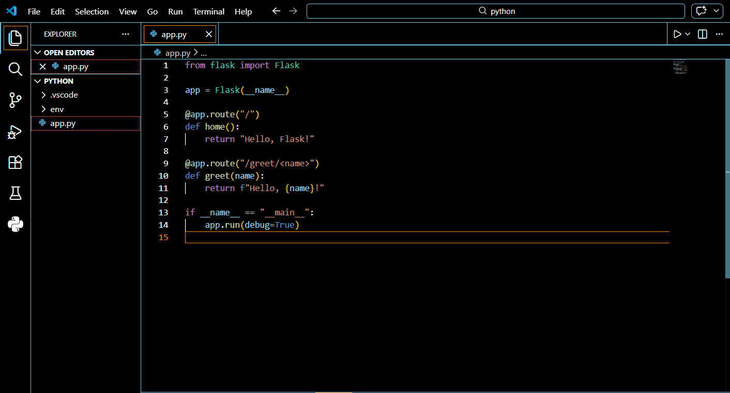

- Running of flask in VS Code
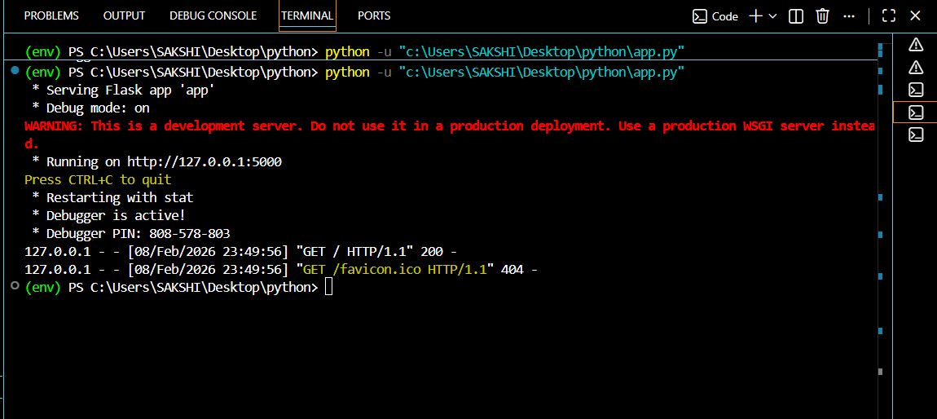

- Flask API Code is Running on the VS Code

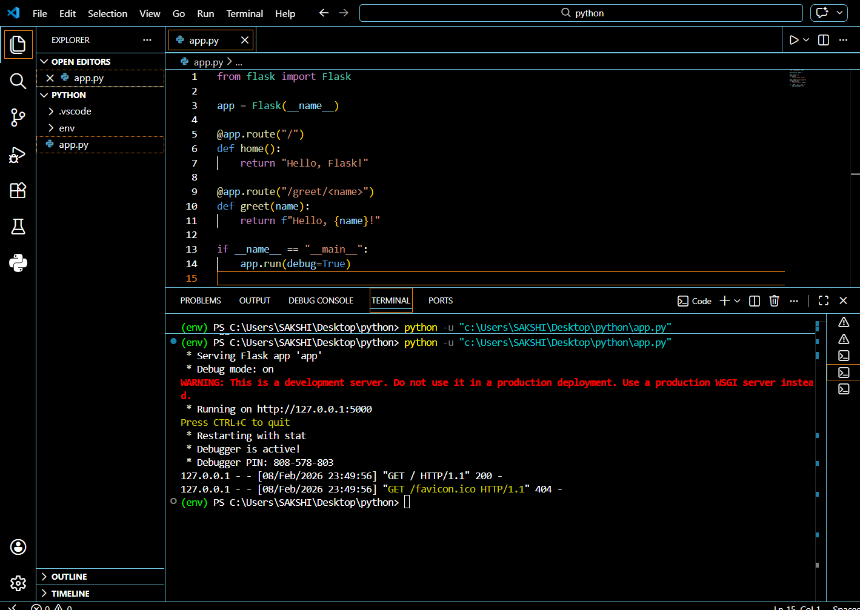

OUTPUT :
